**EVEREST ENGINEERING COLLEGE**

**(Affiliated to Pokhara University)**

**Sanepa-2, Lalitpur**



**[Subject Code: CMP 290 ]**

**A MINI PROJECT MID TERM REPORT ON**

**“Avion Ticket Reservation System”**

**Submitted By:**

**Anshika Bhatt [20120005]**

**Prashant Chaudhary [20120039]**

**Salina kc [20120049]**

**Suraksha Giri [20120059]**

**Submitted To:**

**Department of Information-Technology Engineering**

**September, 2022**

# ABSTRACT

Avion Ticket reservation provides a simple interface for maintenance of airline ticket reservation. It can be used by every individual to book an airline ticket. It keeps the feature of booking ticket facility and enquiry about the ticket reservation.

The creation and management of accurate, up-to-date information regarding a ticket system is critically important in the country’s development infrastructure. Avion deals with all kind of airline ticket system, Enquiry about whether the ticket is booked or not, airline information, ticket details, other resource related details too. It tracks all the details of a passenger and airline from day to day update.

Avion makes the management of airline ticket reservation easier as the information of airline, passenger, and ticket can be easily observed and maintained in this software.

**Key Words:** *Avion, Ticket Reservation System.*

TABLE OF CONTENTS

ABSTRACT i

LIST OF FIGURES iii

LIST OF TABLES iv

CHAPTER 1: INTRODUCTION 1

1.1 Background 1

1.2 Problem Statement 1

1.3 Objectives 1

1.4 Project Features 1

1.5 Feasibility Analysis 2

1.5.1 Economic Feasibility 2

1.5.2 Technical Feasibility 2

1.5.3 Time Feasibility 2

1.5.4 Operational Feasibility 2

1.6 System Requirement 3

1.6.1 Software Requirement 3

CHAPTER 2: METHODOLOGY 3

3.1 Introduction 3

3.2 Software requirement 4

3.3 Proposed project block diagram 5

3.4 Entity-relationship model 6

3.5 Working principle 7

CHAPTER 4: WORK DONE AND REMAINING WORK 8

REFERENCES 11

CHAPTER 5: APPENDICES 12

# LIST OF FIGURES

**FIGURE PAGE**

Figure 3.1: Spiral Model----------------------------------------------------------- 3

Figure 3.2: Block Diagram of Proposed System------------------------------- 5

Figure 3.3: Entity-Relationship Diagram---------------------------------------- 6

Figure 3.4: Flow Chart of Proposed System ----------------------------------- 7

Figure 4.1: Work Schedule-------------------------------------------------------- 8

Figure 5.1: Login form on Smart College--------------------------------------- 12

Figure 5.2: New Student Registration-------------------------------------------- 12

Figure 5.3: Fee Form--------------------------------------------------------------- 13

Figure 5.4: Student Details--------------------------------------------------------- 13

Figure 5.5: New Teacher---------------------------------------------------------- 14

Figure 5.6: Teacher Details--------------------------------------------------------- 14

# LIST OF TABLES

**TABLE PAGE**

Table 4.1: Work Table-------------------------------------------------------------- 8

# INTRODUCTION

## Background

As most of the airline ticket booking system work is done manually or is based on randomly work such as ticket management, new booking etc. These all process takes time. If we include all the work which will be based on computer system, then it can reduce time and work. For example: If any passenger have query whether the booking of ticket is done or not, then he/she is not able to check about the ticket. But under this system all the details will be produced by a single click on enquiry about ticket. Avion application digitalize the management system and use single database to store all the information.

## Problem Statement

* To enquiry about the ticket whether it is reserved or not, it was difficult to check in other ticket reservation system but this Avion helps us to enquiry about the ticket just by a click to enquiry about ticket.
* To book the ticket one must have to visit the airport and it consume more time, so Avion helps doing it faster and easier.

## Objectives

* The main objective of the project ticket reservation system is to manage the details of passenger, airlines and to reduce the time to book ticket.

## Project Features

* Provides the booking of ticket from home easily and efficiently.
* It deals with the reservation of ticket and can enquiry about the ticket.
* Some of the features of the proposed system are:

1. Enquiry about ticket :

We can enquiry about the ticket whether it is booked or not.

1. Book a ticket :

We can book ticket of any airlines which are available at the certain time to a certain destination.

1. Admin login :

Admin can have access to any passenger details and their tickets.

1. Contact us :

Here the user can have access to the emails provided if their occurs any problem.

1. Exit System : Close the application.

## Feasibility Analysis

In the following way our project is feasible:

### Economic Feasibility

As Avion is a mini project done by 4 group members there is minimum cost assumed to be required as it is done based on our ideas and online resources. If any customers want to buy the project the price is very affordable and minimum.

### Technical Feasibility

This software is compatible for every computer with windows 7(and higher) as it is built using Visual studio with php code.

### Time Feasibility

The expected time for the completion of the project will be 2 to 3 weeks now.

### Operational Feasibility

Avion is easy to operate and have effective response to the user. This Software does not require any expert to handle as this is simple and can be understood by anyone. The insertion and deletion of information in the software is fast.

## System Requirement

### Software Requirement

* Microsoft SQL
* Visual Studio
* Sublime text editor

# LITERATURE REVIEW

The first project we reviewed was of BTech Days where he performed the college management system project in C# . He had posted the project in April 15, 2020 where he has clearly explained his project. He used Microsoft SQL and Microsoft Visual Studio to create the project. This project included features like Login/Register System, Admission, Manage Fees, Upgrade Semester, Search Student's record, Add teacher, Remove students. The user interface was simple and easy to use. The software provides guidance to the admin to keep track of each student. The admin have the access to the database of system [1].

We also reviewed another project done by Code Space at Oct 15, 2020. In this Project he created a college management project showing application of C#. The Application starts with a nice looking splash form which leads to a login form. The login form will be connected to a database. If the user id and password match the database entries, the user will login to the main form. From the main form, the user can go to the Students form. He can add, edit, delete and view Students List. The User can manage the different Departments and Teachers by adding, editing and deleting them. The Application allows to collect the Fees from Students, and allows to display all the students who have paid and those who have not. Finally, the fees of particular student can be printed [2].

On the basis of our study and research related to college management system, many of the projects related to college management system are limited to student and college information only. Many of the projects that we reviewed contained features like students and teachers details only which we thought is not enough for college management system. The Software used for Registration and Account management were different in many colleges. So we decided to combine the feature of account management, new registration, student information in single software. Smart College holds all these feature and helps for the effective management of college. As we know in educational institute, management is crucial thing, so in order to reduce the efforts of staff we are introducing our system. This system is paperless system and it reduces the overall manpower and the time required.

# METHODOLOGY

## Introduction

We have used Spiral model of Software development. The spiral model is similar to the incremental development for a system, with more emphasis placed on risk analysis. The spiral model has four phases: Planning, Design, Construct and Evaluation. A software project repeatedly passes through these phases in iterations (called Spirals in this model).

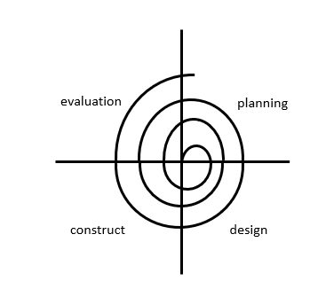

Fig 3.1 : Spiral Model

## Software requirement

* **Sublime text editor:**

Sublime text editor is a shareware cross-platform source code editor. It natively supports many programming languages and markup languages. Users can expand its functionality with plugins, typically community-built and maintained under free software licenses. To facilitate plugins, Sublime Text features a Python API.

* **IDE (Integrated Development Environment)-Visual Studio:**

Visual Studio is an **IDE** developed by Microsoft to develop GUI (Graphical User Interface), console, Web applications, web apps, mobile apps, cloud, and web services, etc. It is not a language-specific IDE as we can use this to write code in C#, C++, VB (Visual Basic), Python, JavaScript, and many more languages.

* **Database Management System(DBMS)-Microsoft SQL:**

My SQL Server for short is the query language provided for data definition and manipulation.

## Proposed project block diagram

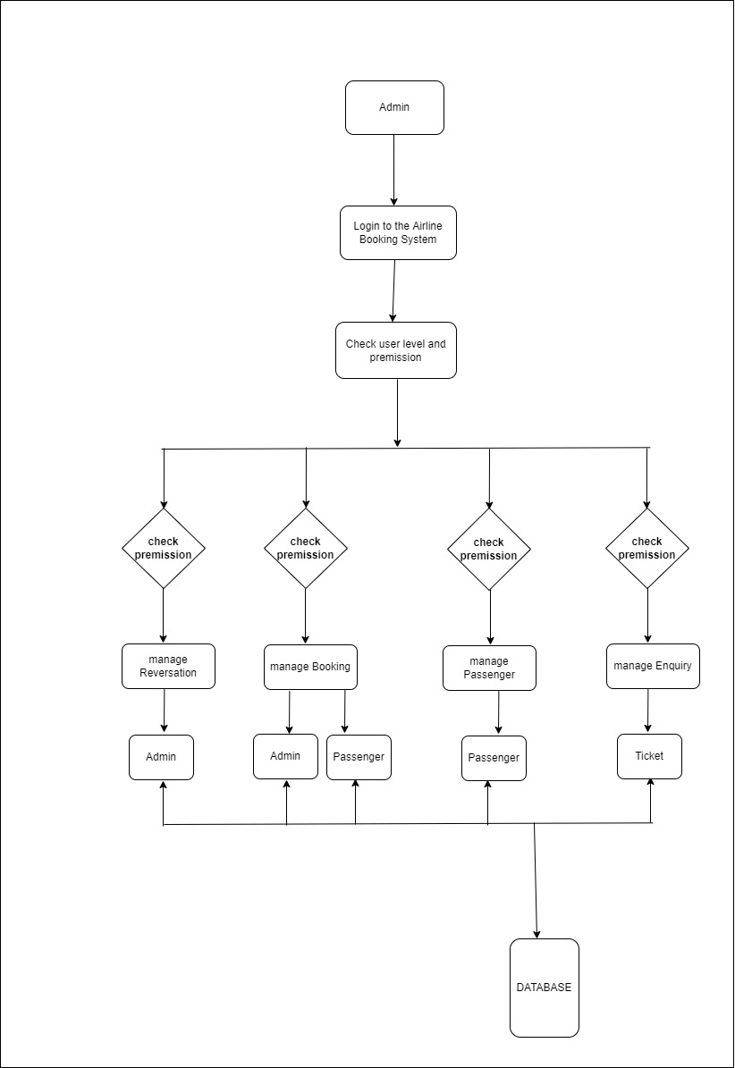

Fig 3.2: Block diagram of Proposed System

## Entity-relationship model

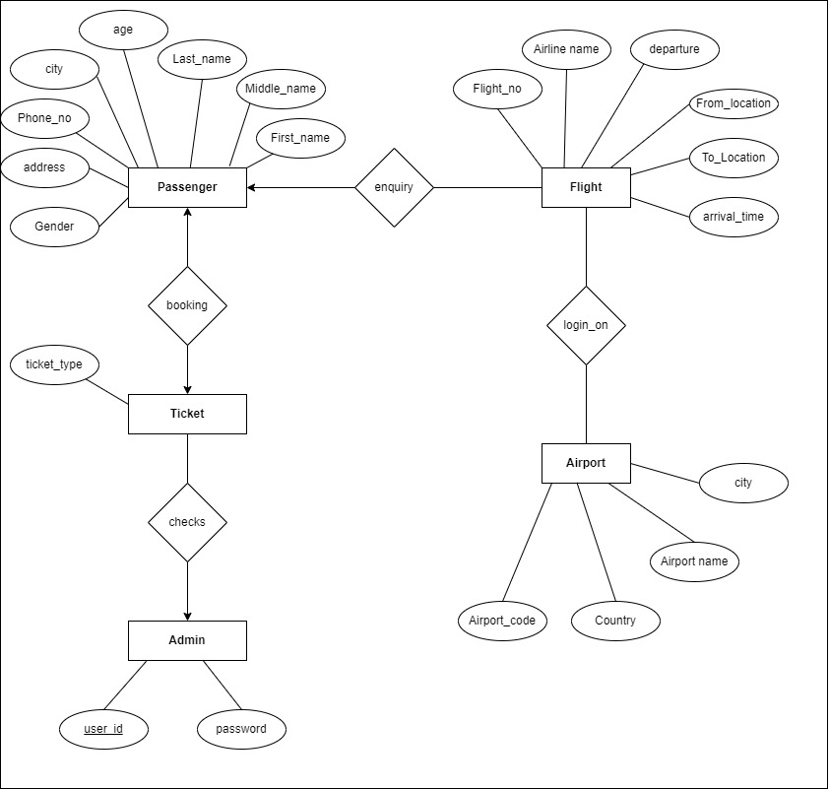

Fig 3.3: Entity-relationship diagram

## Working principle

## Flowchart1.jpg

Fig 3.4: Flowchart of Proposed System

The application starts with a nice looking splash form which leads to a login form. After logging in admin can choose different options like New Admission Form, Account Form ,View Details and Remove Data Form according to the task they want to perform and after finishing the task they can exit the application.

# WORK DONE AND REMAINING WORK

|  |  |
| --- | --- |
|  | WORKS |
| Work Done | Contact us, About us, Book a ticket |
| Remaining Work | Enquiry about ticket, Admin side |
| Table 4.1: Work Table  The working schedule be described as:  C:\Users\hp\Downloads\MicrosoftTeams-image (7).png  Fig 4.1: Work Schedule  Till now we haven’t faced any big problem in our program. Work is expected to be completed within the end of October. | |

# REFERENCES

1. [w3school].Retrieved from https://www.w3schools.com.
2. [Software engineering fundamental Notes for Professional].Retrieved from Ali Behforooz and Frederick J.Hudson(Free Programming Books).
3. "Relation Database Query Language", Lecture Notes in Database Management System.
4. [Geeksforgeeks].Retrived from https://www.geeksforgeeks.org/php-tutorials/

# APPENDICES

We have the output of AVION as shown below. There will be different forms for Admin login, Booking ticket, About us and Contact us.

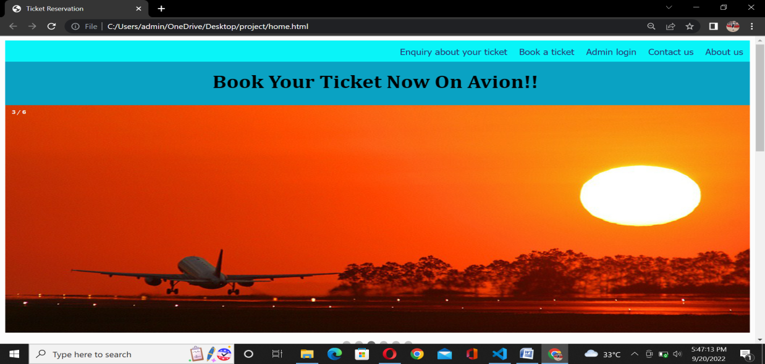

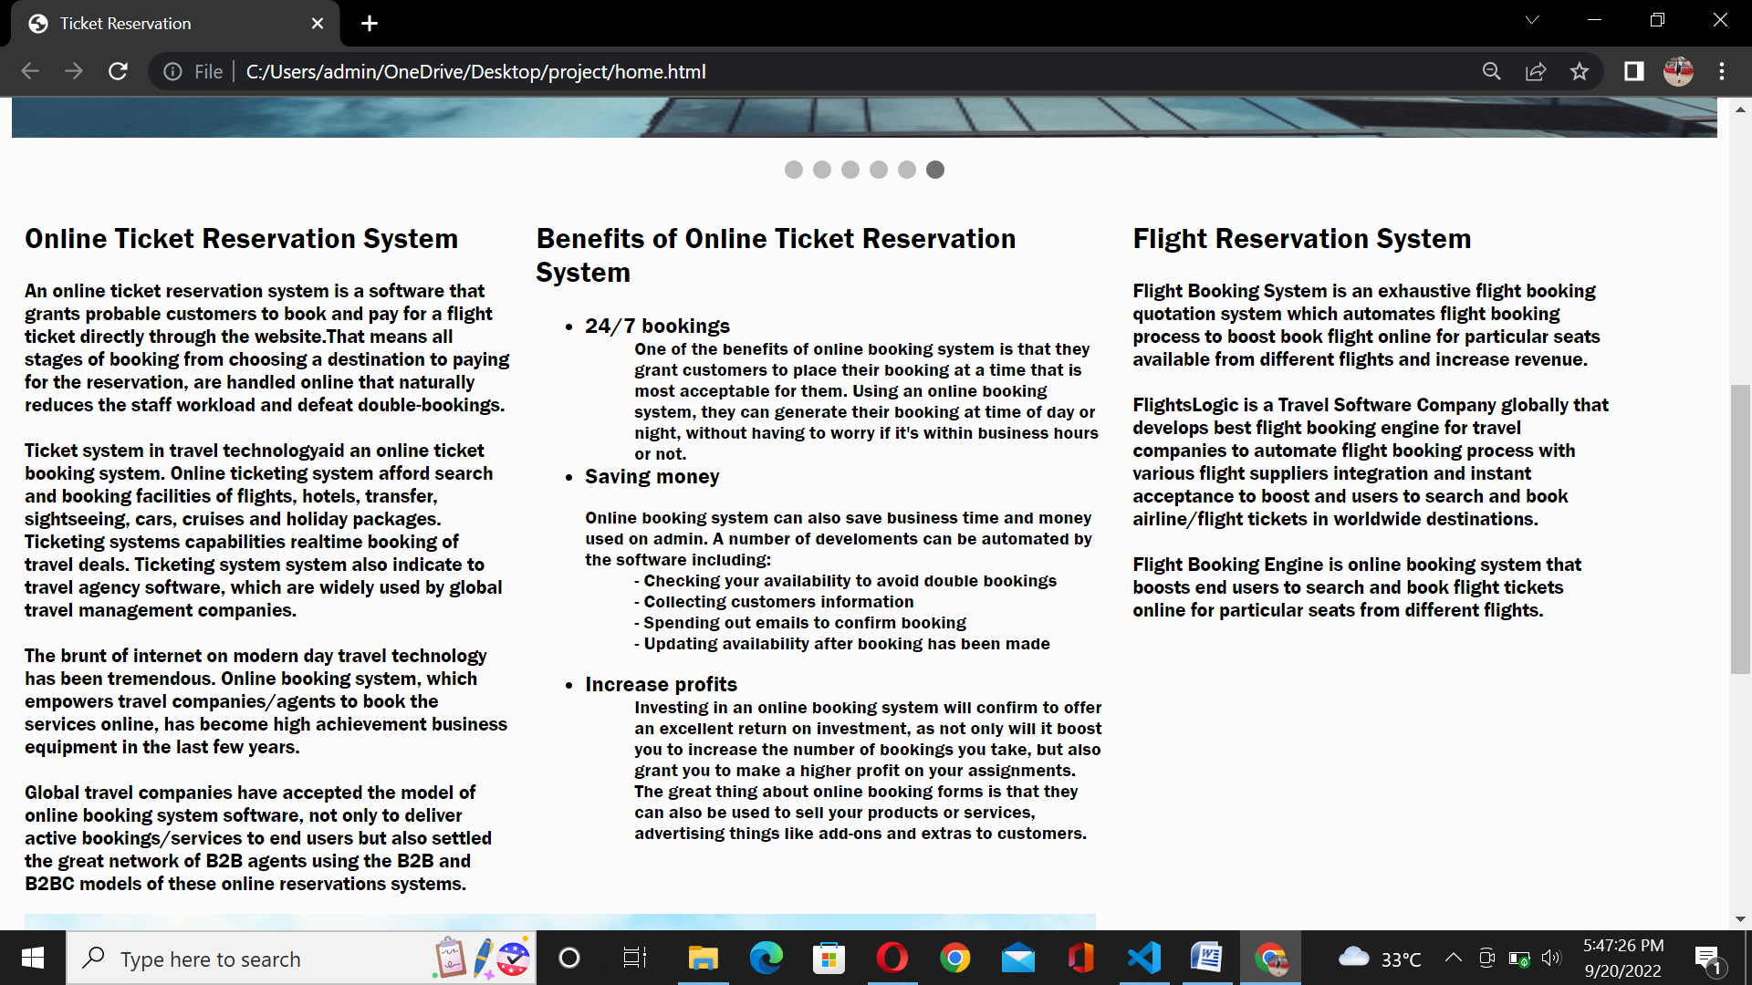

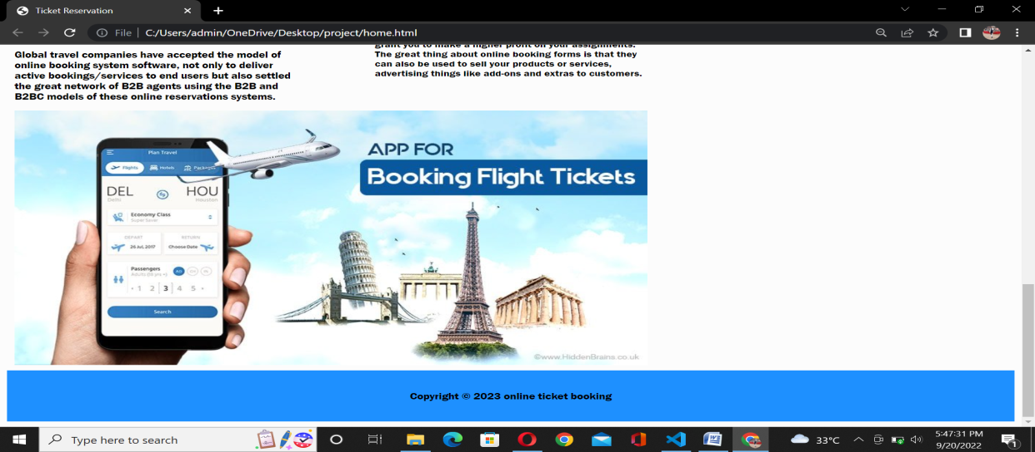

**Fig:5.1:About us**

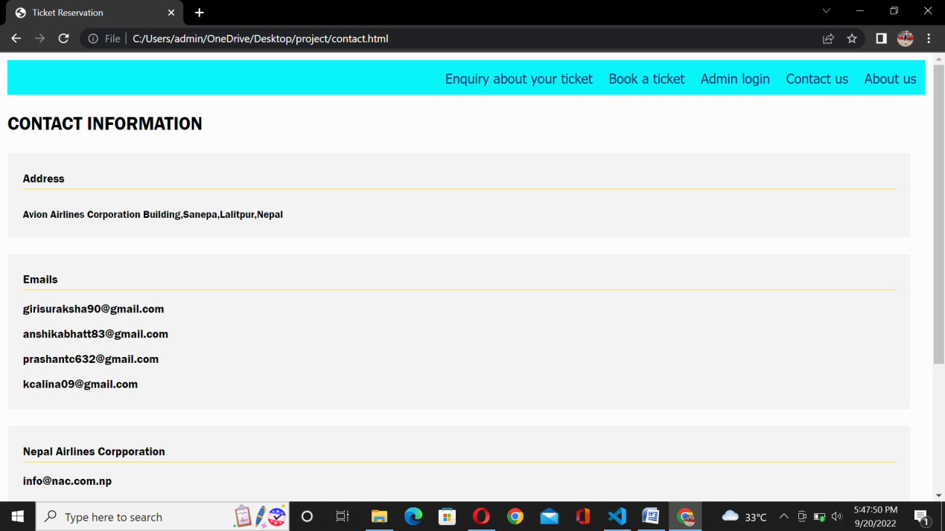

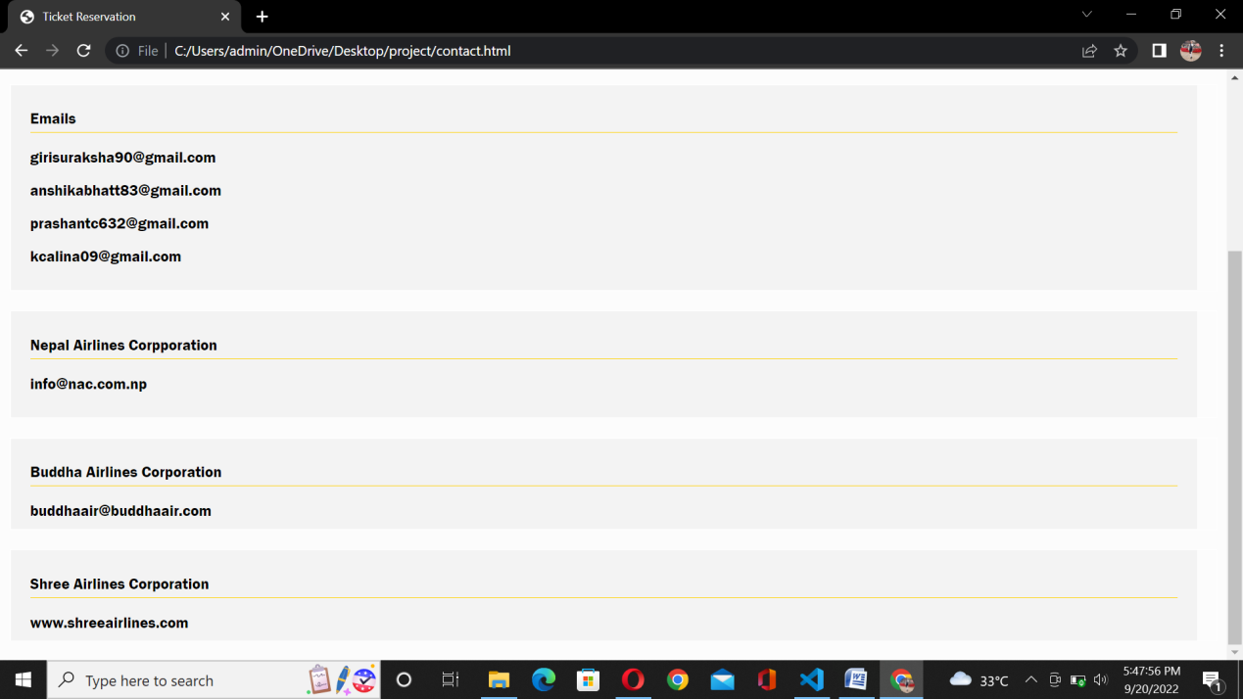

**Fig 5.2: Contact us**

Fig 5.3: Fees Form

Fig 5.4: Student Details

Fig 5.5: New Teacher

Fig 5.6: Teacher Details